Estimate Feigenbaum Number by Simple Diode-inductor Chaotic Oscillator

Yubo Zhi

[yz39g13@](mailto:yz39g13@)soton.ac.uk

Personal Tutor: Professor Alun S Vaughan

Abstract: The diode-inductor chaotic oscillator is an example of chaos system, it has a simple circuit and has the period-doubling and chaos behaviour. By observe the waveform of the voltage across the diode of varying sinusoid input voltage, the Feigenbaum number that describe the rate of period doubling of the chaos system can be estimated.

1. **Introduction**

Chaos, commonly means “a state of disorder” [1]. An electronic circuit with non-linear property can show the chaotic behaviour, which means for periodic input, the output is not necessarily be periodic. The output can be period-doubling, or chaotic, by difference caused by non-linear relationship of the circuit. This experiment will use a diode with an inductor to form a simple diode-inductor chaotic oscillator. Use a function generator to generate a sinusoid amplitude varying input signal, use an oscilloscope to estimate the behaviour of the output.

1. **Background**

Chaotic system is a dynamical system that have several special properties [2]. Firstly that system must be sensitivity to initial conditions, a small change in initial conditions can cause a very different result, which are also called “butterfly effect”. Secondly is must be topological mixing, which means the system will evolve over time so that any given region will eventually overlap with any other given region. Finally its periodic orbits must be dense, which means that every point in the space is approached arbitrarily closely by periodic orbits.

The circuit used is very simple, it consists only an inductor and a silicon diode in series, driven by a sinusoidal voltage source as shown in Figure 1.

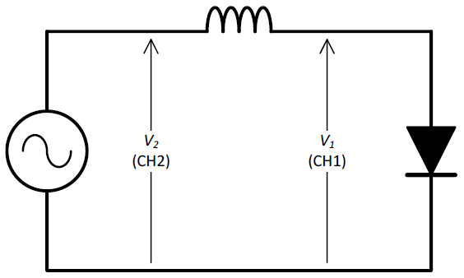

Figure 1: circuit diagram of diode-inductor chaotic oscillator

Since the diode acts as a small capacitor when reversed biased, and acts as a constant voltage source when forwarded biased, it forms a chaotic system. When the frequency or amplitude of the voltage source is increasing, the output waveform of the circuit will undergo period-doubling with the rate of Feigenbaum constant, eventually become chaotic.

There has been some controversy in the literature about the reason that caused this behaviour. Firstly it been thought that the reason is because the reverse capacitance of the diode is not a linear relationship with the reverse voltage, but by detailed mathematical simulations, it has been shown that it is actually duo to the non-zero reverse recovery time of the diode. For the rectifier diode, it will keep conducting for a short period of time after switching between reversed bias and forwarded bias. If that time is significant compare to the period of the applied voltage source, as chaotic system is highly sensitive to the small changes, the chaotic behaviour will be shown. This can be verified by use a fast signal diode instead of the rectifier diode, which have a shorter reverse recovery time, so the chaotic behaviour is more difficult to observe. [3]

An example period-quadrupling of such circuit is shown in Figure 2.

Figure 2: A typical waveform of the diode voltage for the diode-inductor circuit, showing period quadrupling. (Reproduced from [3])

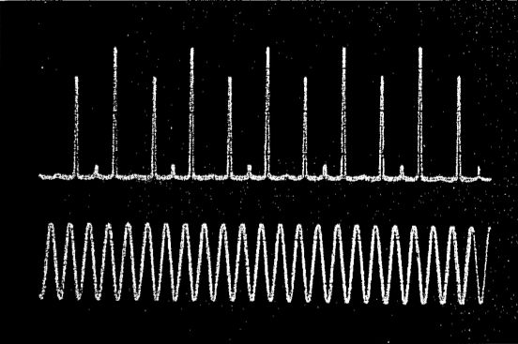

As the period-doubling rate is defined by the Feigenbaum number, so according to Equation 1, the Feigenbaum number can be therefor estimated by record 3 period-doubling point.

$δ=\frac{A_{2}-A_{1}}{A_{3}-A_{2}}$ (1)

Figure 3 is a typical bifurcation diagram, it can also be seen as the bifurcation diagram for this circuit, by consider the x-axis as input amplitude and y-axis as the output amplitude.

Figure 3: Bifurcation diagram of the logistic map. (Reproduced from [4])

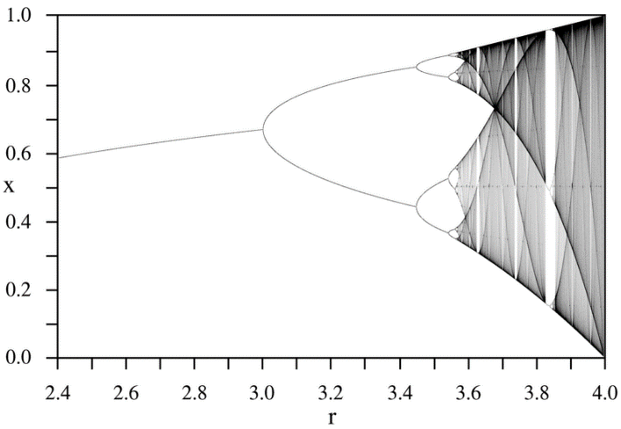

1. **Experimental Methods**

The equipment used in this experiment is a digital function generator as the input voltage source, a diode, an inductor, breadboard for connection and Tektronix TDS2014 4-channel digital oscilloscope for monitoring the input and output waveform.

Circuit connected as shown in Figure 1, with function generator connected on V2, oscilloscope monitoring V2 as input by channel 2, V1 as output by channel 1. The diode is 1N4007 and the inductor is 10mH.

Firstly, setup the function generator to output a sinusoid wave of ~180Hz and ~200mV peak-to-peak voltage to find the resonance frequency at about 180Hz, when the output amplitude become noticeably larger, than choose a frequency near to that frequency, in this experiment I used a frequency of 140Hz.

Then, increase the peak-to-peak voltage output by the function generator gradually, to find the voltage that the output waveform bifurcates, when the amplitude of output waveform become different, means the period of output signal doubled. Record the voltage as A1, and keep increasing the amplitude of input signal to find the point when the period of output signal quadrupling as A2 and octupling as A3. It is very difficult to determine the bifurcation points, and probably with a large uncertainty, so the estimated Feigenbaum number may be quit unreliable.

By repeating the measurements, the result may be more accurate, and an approximate uncertainty can be therefor estimated.

Finally, apply the 3 voltage points to Equation 1, the Feigenbaum number and the uncertainty can be estimated.

1. **Results**

By screen capture 5 times of the waveform of period doubling point shown in Figure 4, when there are 2 amplitudes on the output wave, I got 5 values of A1, the results are shown in Table 1.

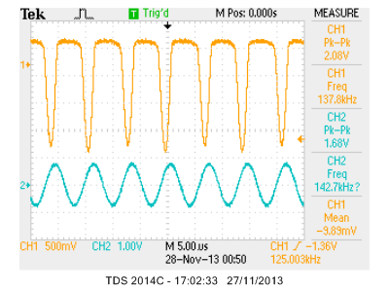

Figure 4: An example waveform of period doubling bifurcate

Table 1: Data of A1, period doubling point

|  |  |  |  |  |  |  |
| --- | --- | --- | --- | --- | --- | --- |
| No. | 1 | 2 | 3 | 4 | 5 | Avg. |
| A1 | 1.68 | 1.64 | 1.68 | 1.64 | 1.68 | 1.664 |

The peak-to-peak voltage set on the digital function generator is 1.48V, with a precision of 0.01V, so the uncertainty of A1 is 1.664±0.04V.

By similar procedure, find the value of A2 and A3.

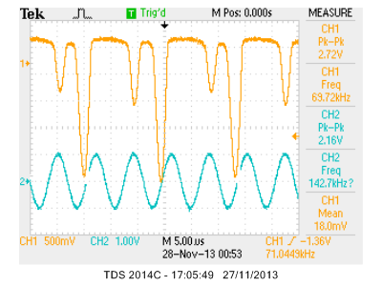

Figure 5: An example waveform of period quadrupling bifurcate

Table 2: Data of A2, period quadrupling point

|  |  |  |  |  |  |  |
| --- | --- | --- | --- | --- | --- | --- |
| No. | 1 | 2 | 3 | 4 | 5 | Avg. |
| A2 | 2.16 | 2.12 | 2.16 | 2.16 | 2.16 | 2.152 |

The peak-to-peak voltage set on the digital function generator is 1.97V, with a precision of 0.01V, so the uncertainty of A2 is 2.152±0.05V.

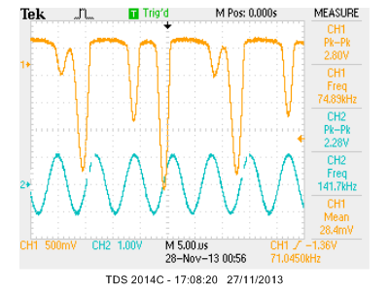

Figure 6: An example waveform of period octupling bifurcate

Table 3: Data of A3, period octupling point

|  |  |  |  |  |  |  |
| --- | --- | --- | --- | --- | --- | --- |
| No. | 1 | 2 | 3 | 4 | 5 | Avg. |
| A3 | 2.28 | 2.28 | 2.24 | 2.24 | 2.28 | 2.264 |

The peak-to-peak voltage set on the digital function generator is 2.1V, with a precision of 0.1V, so the uncertainty of A3 is 2.264±0.13V.

Calculate the maximum possible value of Feigenbaum number, by choose the smallest value of A1 and A3, the biggest value of A2, shown by Equation 2:

$δ=\frac{A_{2}-A_{1}}{A_{3}-A_{2}}=\frac{2.202-1.624}{2.251-2.202}=11.80$ (2)

Calculate the minimum possible value of Feigenbaum number, by choose the biggest value of A1 and A3, the smallest value of A2, shown by Equation 3:

$δ=\frac{A_{2}-A_{1}}{A_{3}-A_{2}}=\frac{2.102-1.704}{2.394-2.102}=1.36$ (3)

It can be seen that the uncertainty of the estimated Feigenbaum number is quiet big, with an average of $\frac{11.80+1.36}{2}=6.58$, uncertainty of ±5.22, which is ±79.3%.

1. **Discussion**

The estimated Feigenbaum number from the experiment is 6.58±5.22, according to [5], the Feigenbaum number should be 4.669 to 3 decimal place, which is in the range of uncertainty.

The uncertainty comes from several different sources, mainly because it is impossible to determine the point of bifurcation accurately, from both equipment aspect and human aspect. The function generator used in carry out this experiment is a digital function generator, which is easier to configure and more stable, but are very imprecise, especially when the peak-to-peak voltage settings is bigger than 2V. The precision of it decreased from 0.01V to 0.1V, lead to a very inaccurate measurement of A3 point. Also the peak-to-peak voltage measurement function on the oscilloscope looks like it can only be measured as multiple of 0.04V, and is somehow different from the voltage set on the function generator. On human aspect, the point of period-doubling is very difficult to determine, it is the point that the waveform become two different amplitudes, one higher and another one lower, that point may just passed before noticed as initially the difference is very small. At the period octupling point, it is very close to the chaos behaviour and the state of passed the first chaos, when the period of the output signal is double of input signal, as shown in Figure 7. The difference between the period octupling point and the point passed the first chaos is as small as it will be just passed within a step of the function generator.

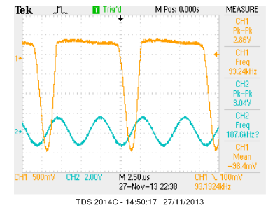

Figure 7: State of passed first chaos

Some improvement for estimate the Feigenbaum number can be made. A complex circuit but more reliable and easier to measure may be used for better investigate. Try to find period-doubling by use varying frequency instead of amplitude may be better. Use an analogue function generator with a precise and stable peak-to-peak voltage adjust will be better than the digital one used in this experiment, as the amplitude of input signal can be fine tuning by an analogue knob at the point of A3. The measurement taken by the oscilloscope need to be replace by a better way of measurement as well.

1. **Conclusion**

The Feigenbaum number is in the range of estimated value, but the range of uncertainty is very big, so the estimated value is not reliable. A better way for estimate the Feigenbaum number is needed.

**References**

1. Definition of chaos at Wiktionary, http://en.wiktionary.org/wiki/chaos
2. B. Hasselblatt and K. Anatole, “A first course in dynamics: with a panorama of recent developments.”, in Cambridge University Press, 2003.
3. K. Briggs, "Simple Experiments in Chaotic Dynamics" in American Journal of Physics, vol. 55, 1987, pp. 1083-1089.
4. Bifurcation diagram at Wikipedia, http://en.wikipedia.org/wiki/Bifurcation_diagram
5. Sequence A006890 in OEIS, http://oeis.org/A00689